
SURVIVING THE HOME INSPECTION
A home seller's toolkit for ridding the sleepless nights worrying about a pending home inspection.

Must-Do's

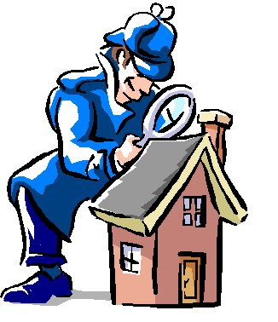 | Inspect Your House Yourself: Grab a legal pad and get started inspecting your own house. Take good notes of all the problems that you see inside and out. Inspect your attic and crawl space too. Repair all the minor items that you can recognize so they don't show up on an inspection report. Your goal is to reduce the trivial items from an inspection report that might overwhelm a buyer. Examples: dripping faucets, loose toilets, sticking doors, loose handrails, etc.

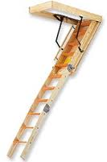 | Provide Access: Make sure that your attic and underfloor crawl spaces are easily accessible. Move personal items and remove padlocks. Don't forget to make sure keys are available for all the deadbolts.  Items that should be particularly easily accessible:  - Electrical panels inside and outside.  - Furnaces, air condensing units, fireplaces.  - Water heaters.  - Outbuildings and detached garages.

 | Have Utilities Turned On: This usually only applies to homes that are vacant, but double check all utilities the day before the inspection to make sure. This can disrupt the entire inspection, and a buyer may ask you to pay for the inspector to come back to re-inspect.

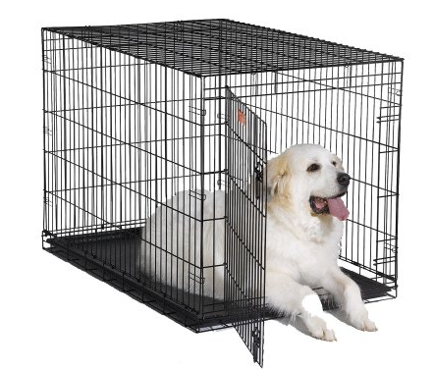 | Remove or Crate Your Pets: There is no greater fear for an inspector than that of mistakenly letting your pet escape or get hurt. Buyers often bring friends and family to the home inspection, and pets get nervous. There are just too many chances your pet could escape. Don't forget that many people are also afraid of dogs, even little dogs!

 | Fresh Light Bulbs: Go through the home and check each light fixture. Replace the bulbs that are expired. You can avoid a comment about an inoperable light in the report with a 29¢ light bulb.

 | Plan to Leave the Home: The home inspection creates a lot of anxiety for the buyer. Home inspectors cannot discuss their findings with you, and they prefer to consult with the buyer in private. If it is at all possible leave the home during the entire inspection. If you must be home, it is best to be friendly but avoid conversations about the inspection. It is, however, a good idea to leave a nice note for the Inspector explaining where items are located like main water valves, electrical panels, etc.

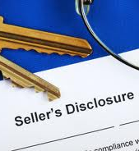 | Be as Accurate as Possible in your Property Disclosure: Buyers get really nervous when inspectors discover that the Property Disclosure is inaccurate. In most cases, sellers make honest mistakes, but buyers still get concerned. Check the serial numbers of your furnace, air conditioner, and water heater. This will give you the correct date of manufacture so you can correctly identify the ages of the equipment on the disclosure form. You may have to use Google to determine how to interpret the serial numbers. Double check receipts from contractors for things like ages of the roof covering.

Easy-To-Do's

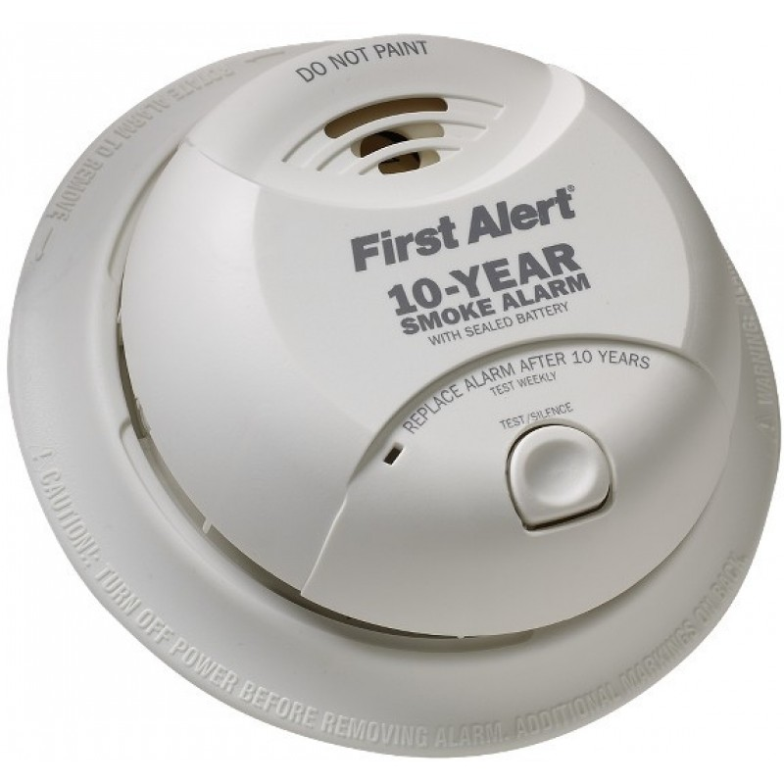 | Update the Smoke Detectors: If your smoke detectors are more than 10 years old, it is time to update them. You should also install them inside each bedroom on the ceilings. Purchase smoke detectors that have a 10-year rated battery, new, but inexpensive, technology. Estimated cost: $60 - $150 for new detectors. Hint: Install a couple of plug-in carbon monoxide detectors too.

 | Termites: If you have a bond and have quarterly inspections, you should be in good shape. If not, you should go ahead and get an inspection from a state licensed pest control operator. It's best to uncover any concerns over termites just before your home goes on the market. Estimated cost: $40 - $75 for inspection.

 | Touch-up Exterior Paint: One of the most common inspection items is concern over flaking paint on exterior wood. Most homeowners can touch-up paint without calling in a pro. Use a wire brush to loosen flaking paint, sand edges, then prime and touch up at exterior wood trim and siding. Repair minor rot with wood epoxy as needed. If there is more widespread decay, call in a handyman. Of course, if your home was built before 1978, learn about lead-based paint hazards at epa.gov/lead. Estimated cost: $60 - $150 for paint, primer, and caulk. Estimated lap siding and trim repair: $4-$5 LF.

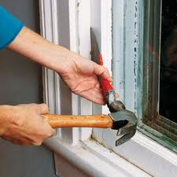 | Get Your Windows to Open: Test all of your windows. Make sure they all open and lock properly. Repair broken locks, remove excess paint, and adjust windows. Most homes that have wood windows will have some that are inoperable. This is an easy thing to fix, and it's a particular frustration to prospective buyers. Estimated cost: $10 - $35 for a five-in-one tool and half-dozen new locks. Hint: test all of your doors too; adjust the ones that don't latch or stick.

 | Trim the Shrubs and Tree Limbs: Most homeowners fail to maintain their shrubs, vines, and hedges. Overgrown bushes and overhanging tree limbs damage a home's exterior. A good rule of thumb is to trim shrubs, hedges, and vines to within 24" of the building. Tree limbs should be cut back to within 6' of the structure. Call a pro if you don't have proper equipment or it's unsafe to reach a tree limb. Estimated cost: $0 - $300.

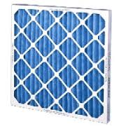 | Change the HVAC filters: Believe it or not most homeowners fail to change their HVAC filters as required. Most should be changed every 2-3 months. It is a good idea to change yours just before the inspection. Why have an Inspector shame you over a $2.00 air filter?

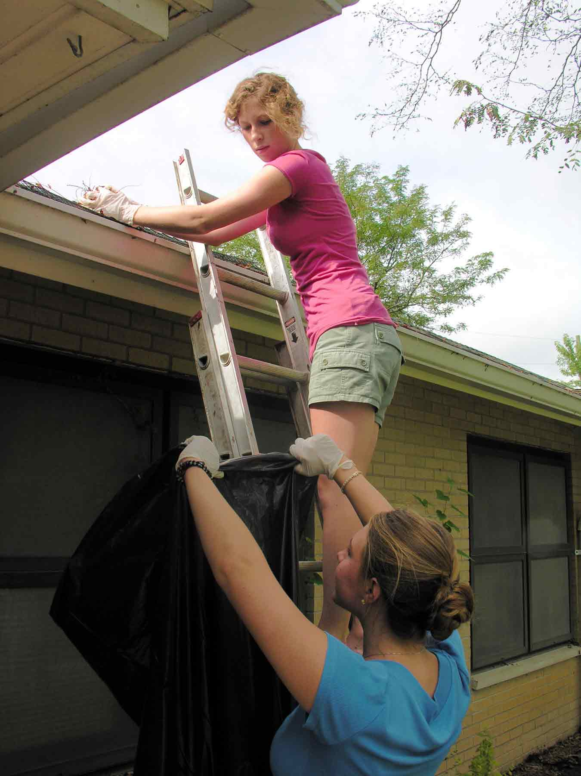 | Clean the Gutters: Clean the leaves and debris out of your gutters. Purchase and install extension pipes for your downspouts. A proper gutter system's purpose is to drain the water away from the foundation.

Should-Do's

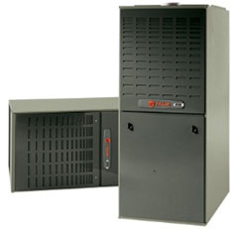 | Have the HVAC Units Serviced: Call a professional, NATE-certified, HVAC company to come out and service and thoroughly inspect the heating and cooling appliances of your home. Make any repairs that are needed. Explain to the HVAC technician that you're selling the home and need the units in tip top shape for the home inspection. Estimated cost: $125 - 500 for tune up and minor repairs.

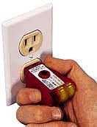 | Have the Electrical System Inspected: Call an electrician to come out and inspect your home's electrical system. The electrician should open the panel, check each and every receptacle, test the GFCI devices, check the lights, check junction boxes, and check circuits. You should strongly consider updating to GFCI devices in the bathrooms, kitchens, and exterior if they are not already present. Estimated cost: $125 - $500 for inspection and minor repairs.

 | Have the Plumbing System Inspected: Call a licensed plumber to come out and inspect your plumbing system. Have the plumber check your water pressure, check for leaks, test toilets, check faucets, and most importantly evaluate your water heater for a code-compliant installation. If you have a gas water heater that was installed prior to 2003, you should consider replacing it even if it still operates normally. Estimated cost: $125 - $500 for minor repairs. Estimated cost for a water heater: $800 - $900 for labor and materials.

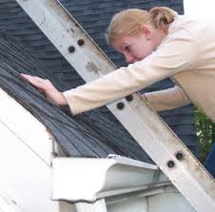 | Have the Roof Inspected and Repaired: Call a certified roofing contractor to come out and inspect your roof covering. Have the roofer check for storm damage, nail pops, holes, abrasions, flashing, and most importantly for check for leaks. Most roofs need general repairs every 4-5 years. Estimated cost: $150 - $500 for minor repairs.

 | Service the Chimney: If you have a wood-burning fireplace, it may be time to have it serviced and cleaned. Have the chimney professionally cleaned by a CSIA certified chimney sweep (csia.org). Have the chimney sweep check your damper, spark arrestor, and gas starter. Estimated cost: $150 - $300 for inspection and minor repairs.

Secrets: Impress the Inspector

 | Leave a Letter of Greeting on the Kitchen Counter: Leave a brief note for the home inspector welcoming him/her to your home. Include basic information about locations of the electrical panel, water valve, furnaces, keys, etc. Acknowledge anything that you know is in disrepair. Let the inspector know it is okay with you to take the time needed for a thorough home inspection. The goal is to communicate to the inspector that you're a reasonable and kind person. You just might guilt the sometimes tough inspector into being "softer" in his wording in the report. Hey, it is just psychology.

 | Clean Your Home. While it is true that the buyer's home inspector is not there to critique the dust on your drapes, a clean home suggests to the inspector that you care about the home and that you have taken pride in it. Home owners who keep a clean house are generally more likely to have also taken care of the repairs in a timely manner.

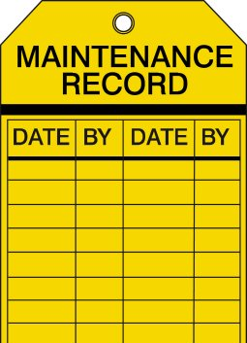 | Maintenance Records: This is a real secret. Now, think about it: would you buy a used Corolla from a sweet grandmother with receipts of all the oil changes, tire rotations, coolant flushes, etc. or buy the same model with same miles from "Slick Pete's Used Cars" who took it in on a trade last week with no history? Want to impress an anal-retentive home inspector? Gather all your records of repairs, home improvements, alterations, etc. Create a one page spreadsheet of the projects, dates, description, etc. Leave this on the kitchen counter with your letter of greeting.

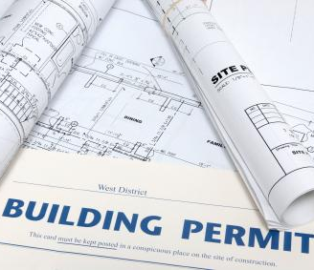 | Building Permit Records: If you have made changes or repairs to the home that required building permits, leave copies of each of the permits for the Inspector and buyer. Likewise, if you have ever had to have a structural engineer evaluate the property, leave a copy of his/her letter regarding the concern. These documents can give the Inspector and prospective buyer added confidence.

 | Rodents and Pests: Most buyers will get more alarmed by the thoughts of pests inside a home more than the thought of a leaking roof or failed air conditioner. If you have ever had a pest problem, get a professional to cure the problem. Additionally, clean all droppings and sanitize any areas where they have visited. Most attics and crawl spaces are vulnerable to rodents. Of course, repair any damaged wiring or ductwork affected by the unwelcomed guests who chewed them.

